Q-Demonstrate Integration by integrating at least three tools.

**1)Integrating Jira with Zephyr:-**



Zephyr for Jira is a comprehensive test management solution that seamlessly integrates with Jira. It allows teams to create, view, edit, and organize test cycles, test cases, and test executions directly within Jira.

Zephyr enhances Jira's capabilities by providing robust test management features. It helps QA and development teams streamline their testing processes, track test progress, and ensure software quality.

**Integration with Jira:**

Create Issue type test

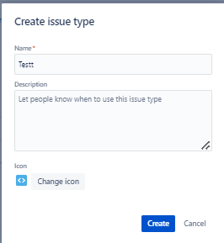

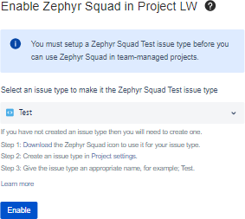

**Test Cases in Jira Zephyr**

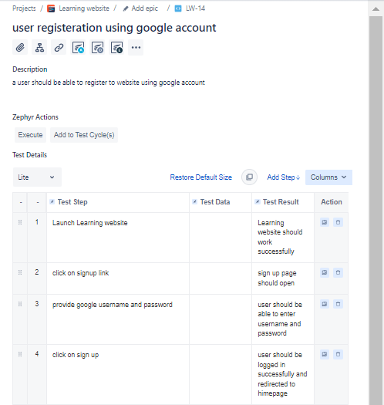

**BDD Test Cases in Jira Zephyr**

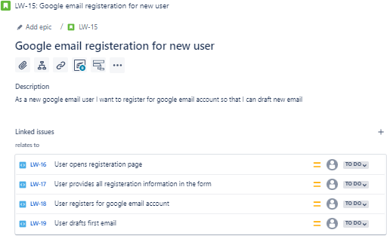

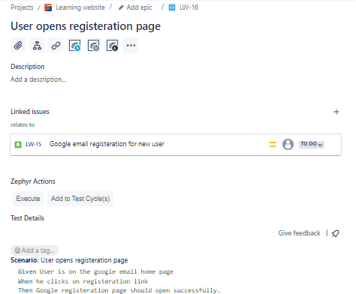

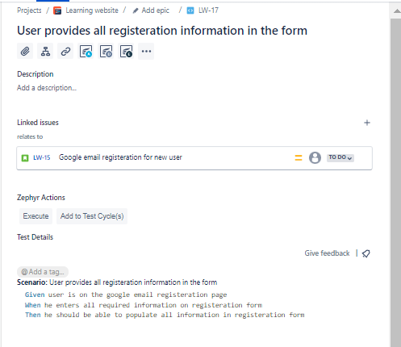

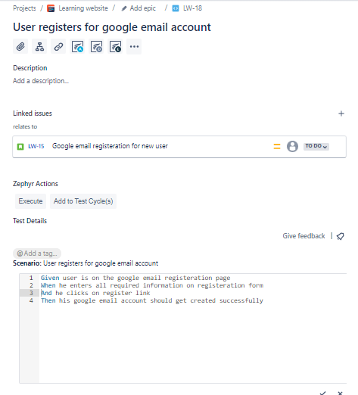

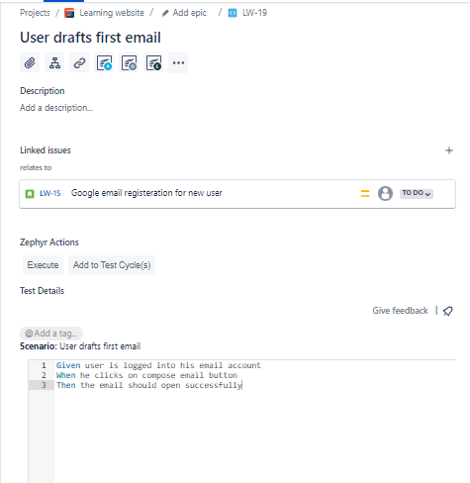

Search Test Cases

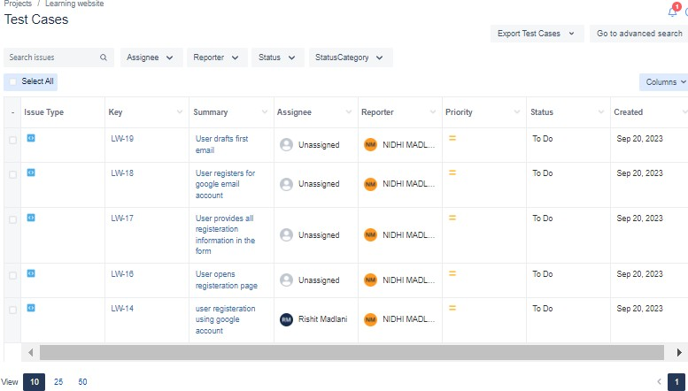

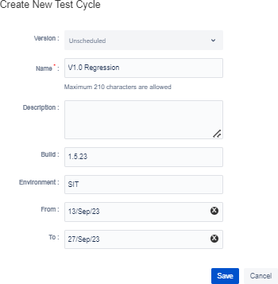

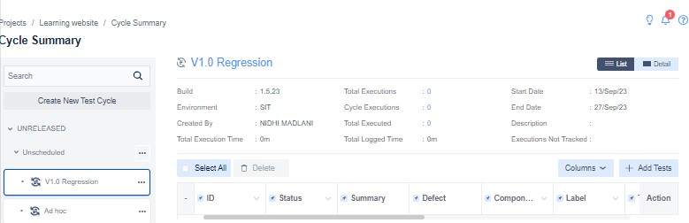

**2) Integrating jira with github:-**

Jira provides a built-in integration with GitHub known as "GitHub for Jira." Here's how to set it up:

1. **Access Jira and GitHub:**
   * Ensure you have administrative access to both your Jira and GitHub accounts.
2. **Install GitHub for Jira:**
   * In Jira, go to "Settings" (cog icon) > "Apps" > "Find new apps."
   * Search for "GitHub for Jira" and install the integration.
3. **Configure the GitHub Integration:**
   * After installation, go to "Settings" > "Apps" > "Manage apps."
   * Find "GitHub for Jira" and click "Configure."
   * Follow the prompts to connect your Jira instance to your GitHub repository.
   * You may need to provide your GitHub credentials and select the repositories you want to link.
4. **Use the Integration:**
   * Once configured, you can link Jira issues to GitHub pull requests and view GitHub activity within Jira issues.

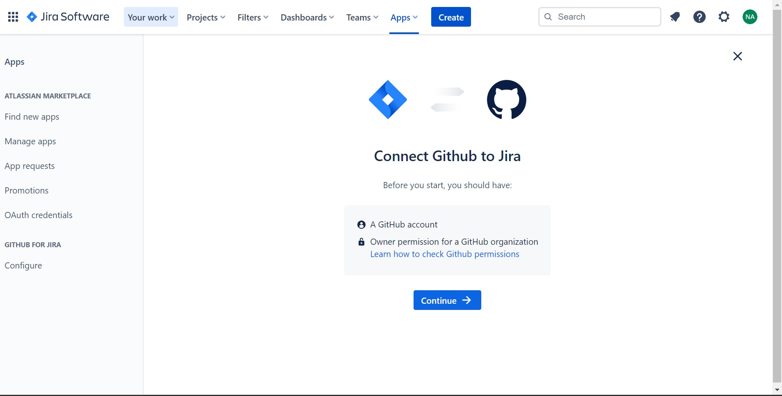

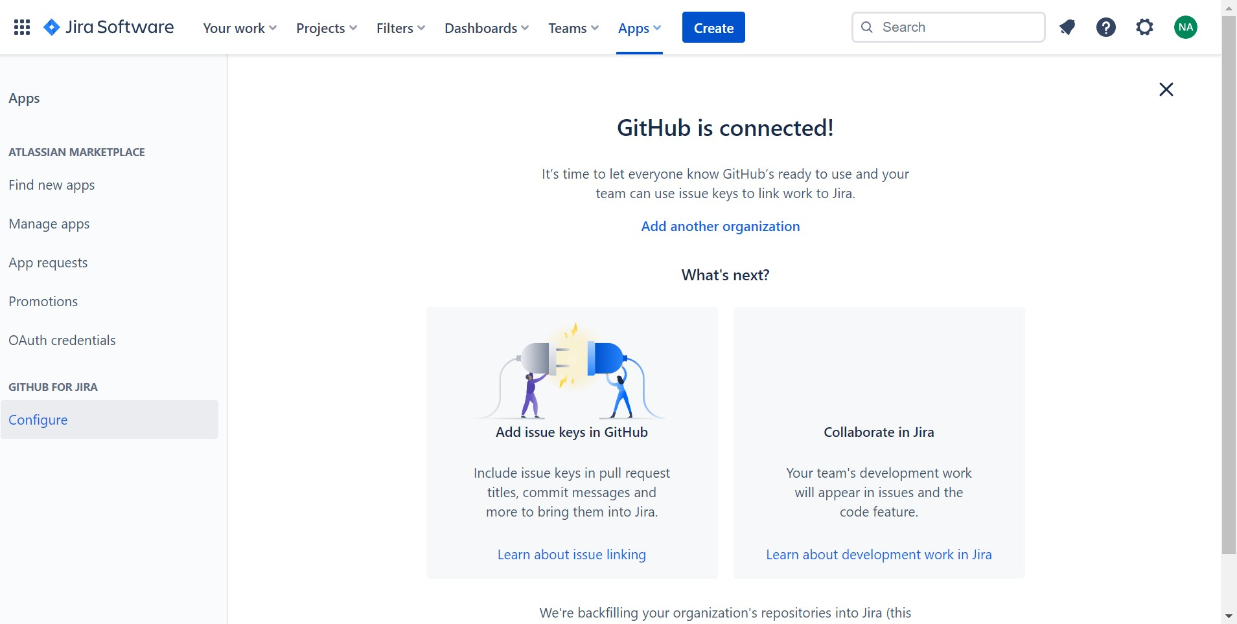

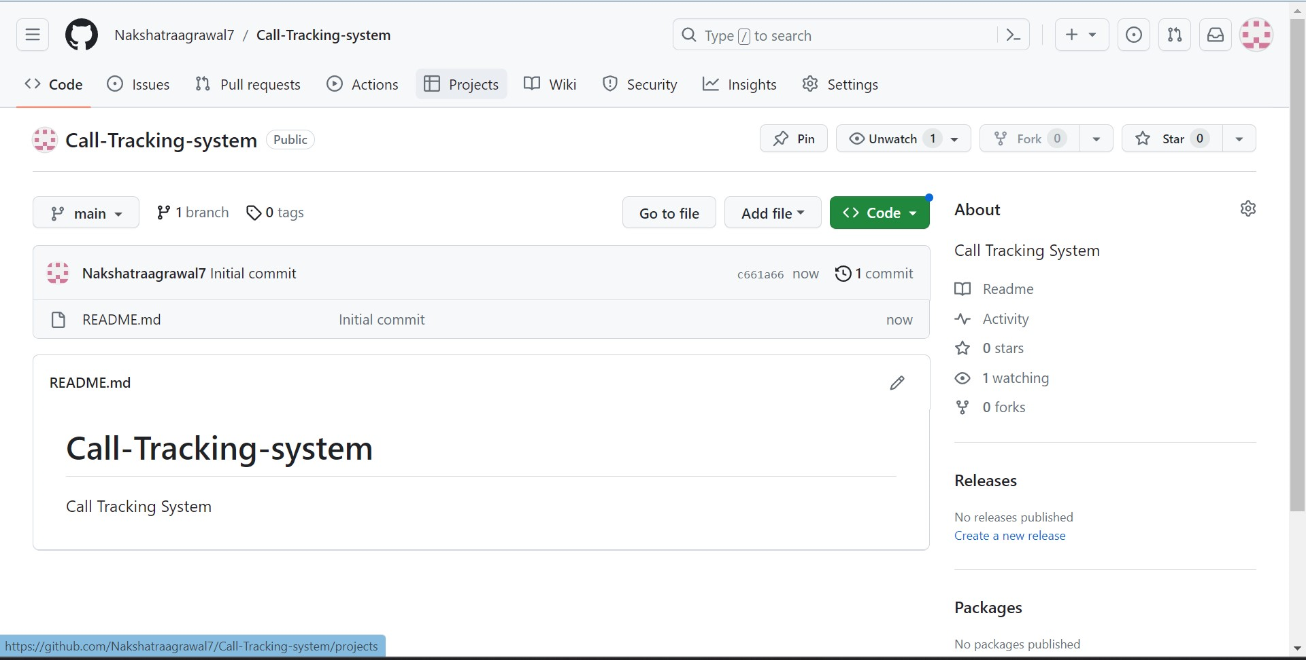

**3) Integrating Jira with Slack:-**

**Use the Jira Cloud for Slack Integration**

Jira offers an official integration with Slack called "Jira Cloud for Slack." Here's how to set it up:

1. **Access Jira and Slack:**
   * Ensure you have administrative access to both your Jira Cloud and Slack accounts.
2. **Install Jira Cloud for Slack:**
   * In your Slack workspace, click on the "Apps" or "More" button in the left sidebar.
   * Search for "Jira Cloud" or "Jira Cloud for Slack."
   * Install the app and follow the prompts to connect it to your Jira Cloud instance.
3. **Configure Notifications:**
   * After installation, you can configure the notifications you want to receive in Slack.
   * Customize which Jira projects, issue types, and events should trigger Slack notifications.
4. **Use the Integration:**
   * Once configured, you will receive Jira notifications directly in Slack, and you can interact with Jira issues and perform actions without leaving Slack.

